Name:____________________
Date:_____________________
Period:___________________
Narrative Writing Prompts
Read each prompt carefully and choose which one you would most like to write about. Any documents you use for brainstorming, a rough draft, and this check sheet/rubric must be turned in with your final draft.
(10% of overall project grade)

- A flying saucer has been sighted over your town. You have never believed in flying saucers, but then you see it for yourself and... Write a science fiction story telling what happens next. Does the saucer land? Do you meet the crew? How do you communicate? What do they look like? Are they friendly? Puzzled? Shy? Suspicious? What about sounds? Sights? Smells? Make your story as interesting as you can for your reader. Create characters and describe the setting. Make your plot move along to a climax and a satisfying conclusion.
- We all have memories connected to our experiences. Think about an experience you feel you'll always remember. Try to picture the time, the place, and the people involved. Try to remember everything you can about this experience. Write about the experience you remember. Be sure to include enough details so that your reader can share your experience. Show why this memory stands out for you.
- Choose something for show & tell, but rather than bringing your object to class, your job is to write a short story that shows us the object and tells us why it's important to you. You'll need to use lots of details to demonstrate the significance of the object -- use your words to create images that show readers the object and why it is important to you.

Instructions:
_____Read each prompt carefully and choose which one you would most like to write about. Write the prompt you choose on the line.
You must write your narrative in 1st-Person Point of View (use the pronouns, “I, me, we, us, our, ourselves, myself, etc.”) or 3rd-Person Point of View (use the pronouns, “he, she, they, them, etc.) and stick with that POV throughout the entire writing.
You must include an introduction and conclusion paragraph along with three body paragraphs (5 paragraphs total). Check the lines below as you finish composing each paragraph. Each paragraph must be at least 5 sentences in length and no more than 8. You MUST use transitions between your paragraphs.
_____Introduction/Exposition – Introduce your reader to the main characters (Somebody), situation (Wanted), and setting (But) you will discuss during your narrative, then transition into your first body paragraph. (5-8 sentences)
_____Body Paragraph 1, continue elaborating on setting, “But” rising action (5-8 sentences) _____Transition was used.
_____Body Paragraph 2, “So” climax (5-8 sentences) _____Transition was used.
_____Body Paragraph 3, “Then” falling action (5-8 sentences) _____Transition was used.
_____Conclusion/Resolution – Focus on your Somebody, Wanted, But, So, Then and tie up any loose ends. Leave the reader satisfied with an ending to your narrative that makes them glad they took the time to read the whole piece (i.e. a surprise ending, a happy ending to a trying experience, etc.). _____Transition was used.
Do not use repetitive language. Use your “smart” words! Find synonyms that are less common for words you use frequently, use academic language based on your narrative topic, use description and sensory details to create a vivid picture for the reader, and utilize figurative language.
_____You MUST give your narrative a title. My title is _____________________________________________.
Rough draft must be double-spaced to allow for proofreading (handwritten so we can work in class)! We will type our final drafts in the computer lab: Arial or Times New Roman, 12 pt font throughout (title may be up to 24 pt font).
BRAINSTORM

SOMEBODY | WANTED | BUT | SO | THEN

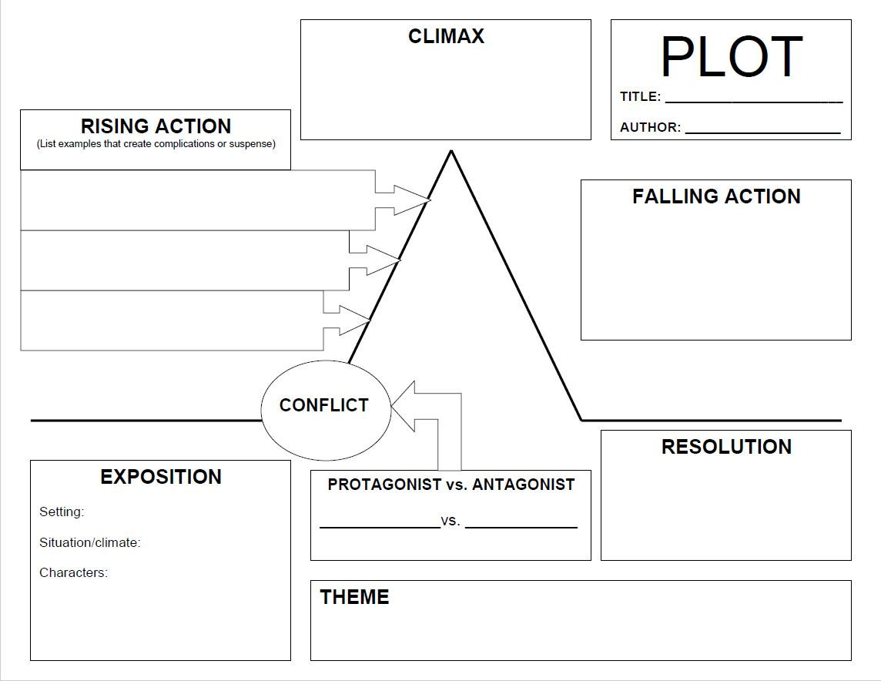

Narrative Writing Project
Final Grade: ________/100
 | 10 | 8 | 6 | 4 | 2
CONTENT
1) Title  Points:_________ | Narrative has a title that is creative as well as appropriate to the topic and main idea. | Narrative has a title that is appropriate to the topic and main idea. | Narrative has a title that vaguely relates to the topic and main idea. | Narrative has a title, but it is not related to the topic or main idea. | No title was included to the narrative.
2) Introduction  Points:_________ | Strong introduction that makes the reader want to find out more, introduces reader to setting, situation, and main characters. | Good introduction, could still use some work, but reader still wants to continue; attempts to introduce reader to setting, situation, and main characters. | Introduction is unremarkable and needs some work, does not grab the reader’s attention and interest; main characters are introduced, but setting and situation are unclear. | Introduction is unimaginative or too obvious, needs to be rewritten; characters are introduced without clarifying their importance to the story, no setting or situation given. | Narrative does not include an introduction, does not provide setting, situation, or introduction to main characters.
3) Idea Development  Points:_________ | Length of paper is appropriate and flows smoothly from one idea to the next. Transitions are clear and evident. | A few instances of clutter and/or not enough elaboration, but flows evenly for the most part. | Good ideas, but at times overshadowed by too much and/or too simplistic writing, making the paper seem choppy. | Narrative is far too long/short and loses focus or is boring because of overwriting and/or no elaboration. | Narrative is incomplete and shows little to no focus on developing a coherent storyline.
4) Voice  Points:_________ | Author’s voice is clearly evident and the piece is thoughtful and well-written in a sophisticated and unique style. | Author’s voice and personality is evident, and effort was clearly put into the piece making it enjoyable to read. | Author’s voice is developing and shows some effort, but at times the piece needs more work. | Author’s voice is sporadic, and the entire story needs more work | Author’s voice is not present, the narrative is bland and unremarkable.
5) Word Choice  Points:_________ | Narrative uses rich and sophisticated word choice, several instances of figurative language, and varied language throughout. | Narrative uses good word choice, some use of figurative language, and some varied wording. | Narrative uses simplistic word choice, only one or two instances of figurative language, and the words are repetitive at times. | Narrative uses simplistic word choice, does not utilize any figurative language, and words are frequently repeated. | Narrative uses simplistic word choice, far below grade level, and excessive repetition throughout.
6) Sensory Details  Points:_________ | Narrative is rich in sensory details and shows rather than tells, creating a vivid picture without overloading the reader. | Narrative has some strong sensory details, making it enjoyable to read, but there may be too few or not enough details at times, telling rather than showing. | Narrative has too few sensory details or far too many so that piece mainly tells rather than shows, or over uses clichés, causing the reader to lose interest. | Narrative is laking in sensory details and tells rather than shows, using empty words and excessive clichés.
7) Conclusion  Points:_________ | Closing paragraph brings closure to the narrative, leaving the reader completely satisfied. | Closing paragraph is good, but does not fully clinch the paper, leaving the reader wanting more. | The ending is too simple – it does not fit the flow of the story or contains weak language, leaving the reader confused | The conclusion to the story is unclear or rushed, leaving the reader confused. | There is no conclusion to the story, leaving the reader confused and unsatisfied.
8) Structure/Organization  Points:_________ | Narrative has excellent structure and is well organized. Sentences are easy to read and keep the reader engaged without confusion. | Narrative has structure and organization, though lacks unity because of occasional confusing details. | Narrative has some structure evident, but at times is hard to follow or is not well organized. | Narrative structure is lacking, events and details are introduced in an illogical order, interfering with the reader’s ability to follow the storyline. | Narrative lacks any type of structure, events and details are choppy and sporadically presented, making it nearly impossible to follow the storyline
9) Point of View  Points:_________ | One point of view was maintained throughout entire narrative. | One point of view was maintained throughout most of the narrative with only one or two instances of deviation. | Point of view changed more than two times throughout the piece. | Point of view was sporadic throughout the narrative, making it difficult to understand who the narrator is. | Point of view changed frequently throughout entire piece, without any true narrator’s point of view evident.
10) Completion  Points:_________ | Narrative is 25-40 sentences in length across 5 paragraphs. | Only one or two paragraphs contain one sentence too many/few, but is still 5 paragraphs in length. | All paragraphs contain one sentence too many/few, but is still 5 paragraphs in length. | Narrative is less than 20 sentences or more than 45, and shorter/longer than 5 paragraphs in length. | It is clear that no effort was given to meet sentence and paragraph length requirements.

Comments:

